Create a Virtual Table for SQL with the Virtual Connector Provider

**Virtual Tables:**

* Creates a table in Dataverse that points to another source.
* Data from the source can be used just like ang Dataverse table.
* Virtual tables can be used in apps, flows, relationships, lookups, and all Dataverse API’s can be used to access the data.

**Virtual Connector Provider:**

* Simplifies creating a Virtual table.
* Some of the steps for creating a standard virtual table are handled automatically by Dataverse.
* A subset of data sources has support for the virtual connection provider.

**Implementation:**

* So, to create the virtual table, first we need a connector. In the left-hand navigation bar.
* Select Data and Connections.

* If our org already has connections, they will appear here and could use them to create virtual tables.
* We’re creating a new one so clicks New Connection or Create Connection.

* Select the data source you want to connect to, their many connectors listed here but, in this case, I’m selecting SQL server.
* Select the SQL Authentication type and then provide additional information about your server, database, and login credentials.

* The gateway credentials are only needed if you’re pointing to an on-premises SQL Server.

* Click Create.
* After the connection is created, a connection reference is needed so Dataverse can communicate through the connection.

* Go to solutions on the left-hand navigation bar, you can either use an existing solution on your system or create a custom solution.

* Inside of the solution>click New>More>and select Connection Reference.

* Name your reference, Select the connector you’re using, in this case SQL, and then you will see your connection in the drop-down list.
* Select it and click create.

* Now, we will need to configure the virtual table in the advanced settings of your organization.

* Click on the gear icon on the upper right of the screen and select Advanced Settings.

* In the top navigation bar, click the settings drop down and pick Administration, and then select Virtual Entity Data Sources.

* Click the New button on the screen and select the Virtual Data Provider from the drop-down list and click OK.

* Name your virtual table source and select the connection reference you just created.

* If you’re creating a SQL connection, you do not need to populate the Dataset Value field.
* Click Save and return of the Maker portal.
* Asynchronous jobs are used to complete the connections to the data source this may take a few minutes.
* When the creation is complete, your tables list will now have a table that starts with **“Entity Catalog”**.
* An entity Catalog is created for each virtual table connection and provides you a list of all eligible tables for use in virtual tables.
* Click the “Entity Catalog” table.

* Click the Data tab.

* Now you can select which of the provided tables you want to create a virtual table for.

* Click Edit in the top navigation bar, now in this page click on Create or Refresh Entity and Select Yes.
* Select a Primary Key and the Primary Field for the entity.
* The primary key must be a GUID field, and the Primary Field must be a string.
* Click Save.

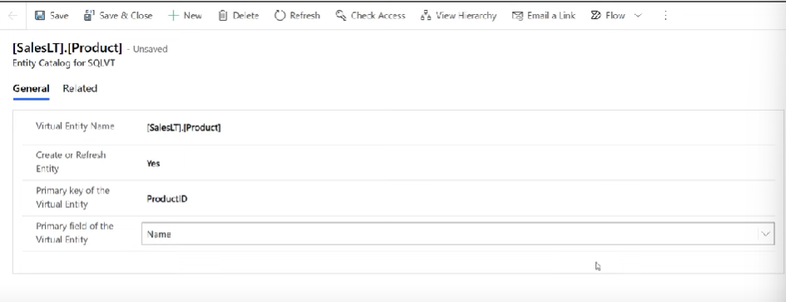

* Return to the Tables Menu.
* An asynchronous job is run to connect to the table and retrieve all the column data and metadata and needed for the virtual table.
* It takes few minutes, Once completed, you’ll see anew table that includes the name “Custom Entity” followed by the name of your virtual table.

* If you open the virtual table and click Data, you can preview the data that’s in your source.

**Limitations of Virtual Tables:**

There are some limitations because the data in the virtual table is not stored in Dataverse, you will not be able to perform rollup calculations or enable auditing on the virtual table.